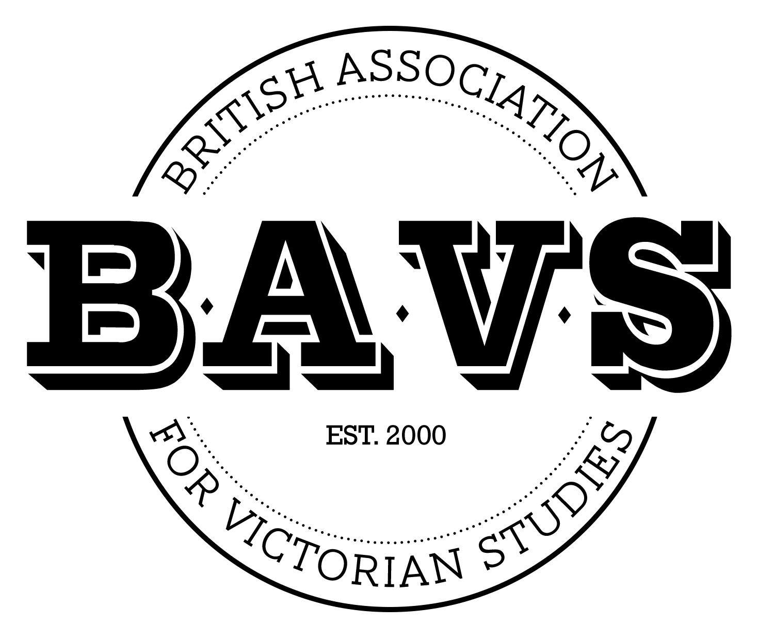

Expression of Interest (EOI) Form to Host the BAVS Annual Conference
The annual British Association for Victorian Studies (BAVS) conference (estimated to take place in July or late August/early September each year) brings together those engaged in research and related activities across multiple disciplines and at all career stages. It is a key annual event in the field.
Applications will be considered at the subsequent Summer, Spring or Autumn BAVS Executive Committee meeting following receipt of this form by the BAVS Secretary, Dr Claire Wood (claire.wood@leicester.ac.uk).

Date | Note 1st 2nd & 3rd choice
Summer 2026

Summer 2027

Summer 2028

Proposed Host Institution venues & facilities
This section should indicate the venue/s at which you propose to hold the conference. You may also wish to reflect on any potential hybrid/digital conference elements in this section.

Conference Team: (add rows if required)
Please note that BAVS expects the conference organising team to be multidisciplinary, and spread across regional institutions where appropriate
Name | Institution | Department | Position

Rationale (max 300 words):
This section should explain the rationale for your proposal

Location: (max 300 words)
This section should outline the benefits of hosting the BAVS conference in your university and region

Team: (max 500 words)
This section should explain the rationale behind the composition of the organising team and how members will contribute to conference planning and execution

Lead Conference Organiser/s: (please add rows if required)
Name | Email

Lead Institution Approval: (Head of Host School/Department):
I endorse this application and, if successful, will ensure that the planned activities and expenditure will be appropriately facilitated.

Signed: Date:

Successful applicants will work with support from a sub-team or members of the BAVS Executive Committee, who can provide guidance and advice on delivering the annual conference. The lead organiser/s will be asked to provide regular updates on the conference plans at Committee meetings.
Please note that it is often usual practice for conference profits to be shared with BAVS, which are then used to continue to facilitate further work of the membership in the field of Victorian Studies.
Please return this form to BAVS Secretary, Dr Claire Wood (claire.wood@leicester.ac.uk).
All proposals will be considered by the BAVS Executive Committee, and lead proposers informed of the outcome as soon as possible thereafter. We encourage early applications, where possible.

